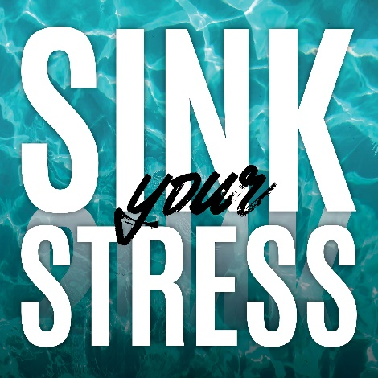
FREQUENTLY ASKED QUESTIONS
WHAT is the GOAL? Over the three weeks of the program, begin to develop healthier habits to manage your stress through movement, nutrition, time management, sleep, and healthy connection. Each week you will receive 6 weekly challenges to help support your stress management. You can choose which challenges you would like to work on – maybe all 6 or maybe just a few. Throughout the program you will have access to expert tips and resources.
WHEN? The program will begin on Monday, April 3rd and end on Sunday, April 23rd.
HOW DO I PARTICIPATE?
- Register for the program at: https://studentwellness.uiowa.edu/programs/sink-your-stress/
- Review each week’s goals.
- Each week try to complete as many of the challenges as possible from the gameboard. You can track your progress on a printed gameboard or use the quiz tool on ICON (you will be added to the course shortly after registering for the program).
- At the end of the program, complete the evaluation (emailed to all who register for the program) to register for a prize.
- Watch for weekly emails with helpful tips and resources for completing the Sink Your Stress challenges!

I REGISTERED, BUT I HAVEN’T RECEIVED ANY EMAILS ABOUT THE PROGRAM:
Your email may have been entered incorrectly on the registration! If you do not receive an email confirming your registration, there may be a problem with the email address entry. Contact haley-melchert-1@uiowa.edu to check on your registration (and to correct the email address, if needed).
WHY DO THIS?
Over the last year, college students have been under a great deal of stress. Many students have experienced changes in their physical activity levels, eating habits, and sleep routine and are feeling more disconnected than ever. We hope that through participating in Sink Your Stress, you can begin to re-balance your habits to help better manage your stress and feel more connected.
WHERE DO I TURN IN MY TRACKING FORM/GAMEBOARD?
You do NOT have to turn in the tracking form/gameboard. Simply complete the final evaluation which will be emailed to you after the final week of the program.
WHAT IF I CAN’T ACHIEVE ALL THE CHALLENGES EACH WEEK?
The goal is not to accomplish all 6 challenges each week, but to find which challenges best support you and your stress management. We are confident everyone who tries to meet at least one of the weekly challenges will experience some positive changes!
HOW DO I GET MY PRIZE?
When you complete the evaluation, you will receive an email with instructions on picking up your prize for participating in the program.
Everyone who participates (registers for the program and completes the evaluation at the end) gets a prize (cutting board, salad shaker, water bottle or ear buds). The evaluation is emailed to all registered participants the last week of the program.

