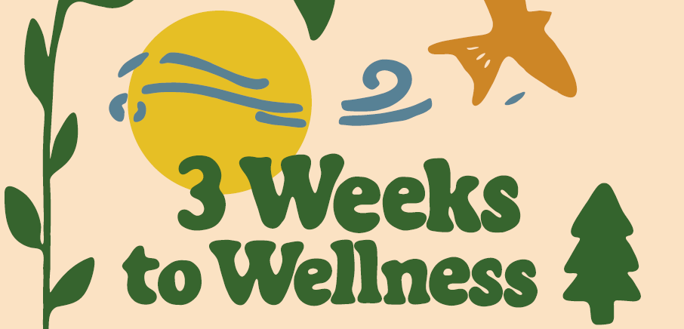


Frequently Asked Questions
WHAT’S THE GOAL OF THE PROGRAM?
The goal is to take one step per day to establish healthier habits that can be easily incorporated into any lifestyle. Healthier habits can improve your overall wellbeing, and you can experience the benefits without investing a lot of time or money. We hope this program helps you identify what is most supportive to you!

WHEN?
The program runs from April 6 – April 26, 2026. You have 6 weeks to take steps to improve your well-being!

HOW?
1. Register for the program at 3 Weeks to Wellness | Student Wellness - Division of Student Life | The University of Iowa
2. Download/Print the 3 Weeks to Wellness game board.
3. Each day from April 6 – April 26, try to complete one goal from the board for that week. Once you’ve completed the task, check the box on the gameboard.
4. At the end of the program, complete the evaluation to receive a prize for participating in the program, as well as being entered to win one of three prize packages of various wellness items.

WHAT IF I REGISTERED, BUT HAVEN’T RECEIVED ANY EMAILS ABOUT THE PROGRAM?
Your email may have been entered incorrectly on the registration! If you do not receive an email confirming your registration, there may be a problem with the email entry. Contact lindsey-norman@uiowa.edu to check on your registration (and to correct the email if needed).

